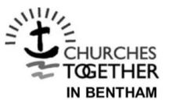
'CARING FOR GOD’S WORLD'

December 2020.
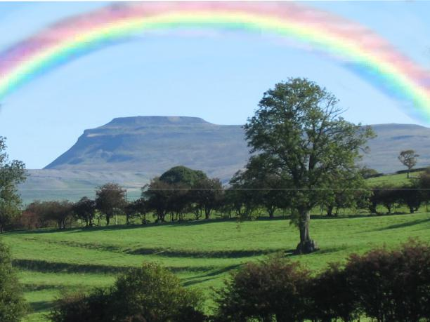

7th Edition

CONTENTS

 | Page
Silver At Last and Eco-Bricks | 2
What’s Happening at St John’s? | 3
Community Gardens and Allotments | 6
Eco-School – Bentham, Stonegate and Cedar House | 7
The 7 R’s | 7
Forget Recycling…. | 9
Possessions and Stuff | 10
Eco-Justice | 11
Make COP Count | 12

Silver at Last and Eco Bricks by Andy Ive

St Mary’s, Ingleton.

I am pleased to announce that St Mary’s have at last attained the silver Ecochurch award for the work carried out to date. There are 5 categories, and St Mary’s team have scored gold in 3 categories, let down on 2 areas by the heating system and the churchyard, but we will get there.

The award scheme has certainly brought the plight of the environment to the minds of the church leaders and the congregation. We live in a time of great change, and no one can say they have not seen the clips of Sir Richard Attenborough talking about the climate, plastics and the destruction of the rain forests. In Indonesia palm oil plantations are making a handful of people rich, and the planet very poor.

We need prayers to stop the destruction of this garden of Eden that God has given us, so keep praying

ECO BRICKS

Well for the past year I have been making these Ecobricks that featured in a

2

previous copy of this magazine, But what to do with them once they are made? Well, we finally got to use 80 of them by building a hedgehog house in the garden.
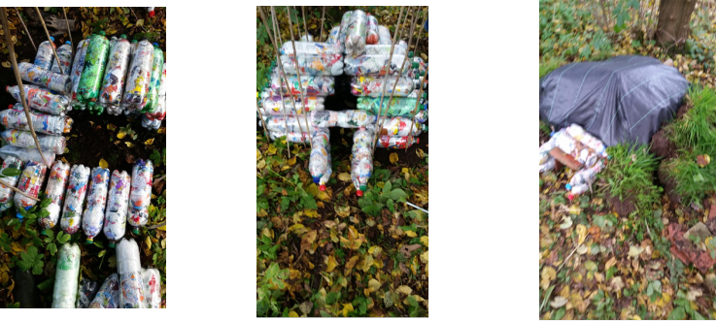

I do hope our guests enjoy their new home, Hedgehogs have declined up to 30% in urban areas and 50% in rural areas since the Millennium. Let’s give ‘em a hand/home.

WHAT’S HAPPENING AT ST JOHN’S

Thank you everyone for all you do to look after this part of our family home, I

mean this world God has given for us to live in, to enjoy and supply our “daily

bread”.

For the word of the Lord is true and all his works are sure. He loves righteousness and justice; the earth is full of the loving-kindness of the Lord. By the word of the Lord were the heavens made, and all their host by the breath of

his mouth. Psalm 33

Last year, 2019, the PCC formally committed us to be an Eco Church and St John’s were awarded silver in the Eco Church scheme, run by A Rocha.
Please note Craven District Council has declared a climate emergency and their intention to go carbon neutral by 2030/2050 and BEST Climate Action continue to make Bentham a “Sustainable Town”

- Worship and Teaching: Much of our worship with special services in May 2019 and September 2019 (in Ingleton) and in churches in the Ingleborough Team during the Creation Season,

3

September 1st – October 4th, and some of our teaching include eco elements, such as the intercessions – in children’s activities such as the anti-plastics banner used in the Bentham carnival. New Altar Frontal made with tapestry scenes from Nature, designed by Marianne Corless.

- Buildings: Because St John’s is a listed building, we cannot

put in insulation or double glazing. We now get both our electricity and gas supplied from renewable sources through a diocesan scheme. The Rectory is fully insulated and double-glazed. Some cleaning products are eco-friendly. We use recycled paper for printing.

Possible actions: re-calculate our carbon footprint in July 2021; reduce paper and printing usage? Pew sheet sent by email? To install screen for OHP service words and readings, etc. To ensure BREEAM standards in planned improvements to building.

3. Community and global engagement. A lot of this is with and/or through individuals and local environmental group, BEST Climate Action. Fair Trade products used and promoted. Some car sharing. Editions of the quarterly Caring For God’s World, (CFGW) are published. Doris Cairns of Ingleton has done an informal survey of plants in the churchyard, including Snowdrop Field. Your eco rep and others have attended conferences about responding to the climate crisis. Some of the food we offer is LOAF, local – organic – animal-friendly – fairly traded.
Possible actions: more people to be involved with this, for

example contributing articles to CFGW; sharing in Bentham (BEST) climate action group; campaigning; litter-pick with nature walk; more car sharing; support for environmental
projects in Sudan with money, prayer and campaigning. 4

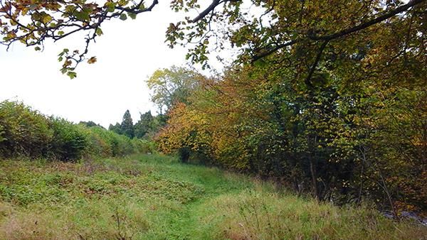
Snowdrop Field in

Saint John's

Churchyard

- Land, ie, Churchyard including “Snowdrop Field”. Thanks to churchyard team for excellent work managing the whole churchyard to encourage wildlife, eg, orchids, other flowers, tawny owl – beehives installed, bird boxes, bug houses (cut timber left in

piles) – bats, hedgehogs, etc - as well as keeping approach to the church tidy and colourful. A path has been mowed down Snowdrop Field and the brambles reduced and rubbish cleared but the rest has been left to allow wild flowers and other wildlife to thrive. Leaflets for prayer and reflection are in the porch and church. [ A recent visit by Doris Cairns revealed we have 2 kinds of yew, Spanish and English. Did you know that yew needles have a chemical, a poisonous alkaloid that can be converted into a cancer drug?]

Possible actions: We are planning publication of a booklet about the wildlife in the churchyard with help of Doris Cairns and Judith Allinson, both botanists. Living Churchyards project Caring For God’s Acre – to advise.

- Lifestyle Let Timothy know if you are making any changes to your lifestyle for example, energy use, travel (pre-lockdown or plans for future holidays!), waste recycling or re-using, use of plastic , home insulation, shopping habits (!) - to help us work

5

towards our Gold Eco Church Award. Use own mugs for coffee in church, when we can have coffee after church services! See the 7 R’s.

Notes from a report to St John’s Parochial Church Council – July 2020

COMMUNITY GARDENS & ALLOTMENTS

Bentham Coop and people in the town are looking for funding and land for allotments and community gardens. Carolyne Lobb writing in the September Bentham News says they now “have a list of 30 people who would like their own allotment space to grow produce, get some space and some time to themselves whilst also enabling good physical and mental health.” Anyone interested is asked to contact Carolyne on 015242 62512 – or by email: carolyne.lobb@coopmembers.co.uk

And have you seen the Community Orchard in Burton-in-Lonsdale? Well worth a visit – and then go on for a walk through Greta Wood.
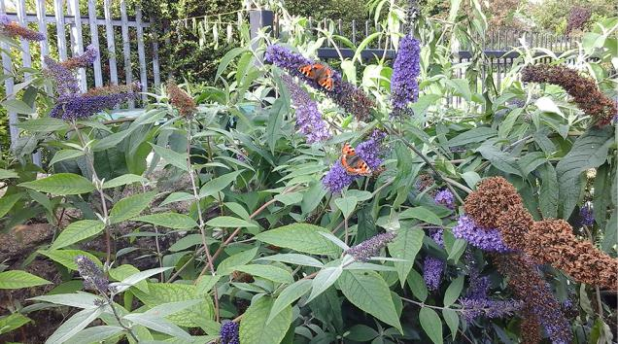

Tortoiseshells on Budleia

BUSY BUZZY BEES IN BENTHAM

When we come to choose plants for our gardens think Bees! A swarm has been introduced into woodland near the town with support from various bodies as reported by Sandra Silk in the Bentham News for August 2020. Two hives have been set up at St John’s waiting for bees to arrive hopefully in the Spring next year. And see the November 2020 Bentham News for Joyce Knapp’s advice on wild flower planting – for example sow seeds now if you have not done it in the Autumn – and clear some of the grass away as the grasses tend to suppress other plants.

6

ECO-SCHOOL

(from a report in the Craven Herald by Lesley Tate)

Children Grow Their Own Green Activity

“Bentham Primary School was awarded a grant from Yorkshire Dales Millennium Trust’s coronavirus community fund to ensure children and staff remained connected and creative during the coronavirus pandemic.

“Some 140 students received a Grow Your Own Activity Kit over the summer which enabled them to grow various seeds and learn about plants, flowers and gardening.” (from Tessa Tyndall)

Stonegate School regularly check their carbon footprint, learn about flower and vegetable gardening, recycle rubbish, do a litter pick in the village, make bird feeders - and for this they have received a Silver eco award.
(from the Bentham News, September 2020, by Viki Hindle)

Cedar House School provides some fantastic facilities for their students (people with special educational needs) including “a fully functioning Hair and Beauty Salon which provides treatments for pupils and staff within school, a Horticulture and Land Based Studies Hub which includes an animal enclosure, a poly tunnel for propagating plants and an array of tools and machinery which is used by the pupils for grounds maintenance around the school site.”

THE 7 R’s

I expect you know about the 3 R’s as a way of reducing the damage we are doing to the Planet – “Reduce, Reuse, Recycle”. And we are all trying to reduce our carbon footprint in other ways.

But how about the 7 R’s?

Rejoice Take a delight in the natural world and in all it gives us. Thank God for all his creatures and for all that is free to enjoy. Celebrate the goodness of life, its amazing variety and superabundance, and the skills we are given to use its benefits.

7

Refuse Refuse to believe what the adverts tell us. You are no less a person if you don’t have the latest gadget. You need not rush to buy something that everybody else has.

Reduce Cut down on the number and length of journeys you take by car or plane. Reduce the anxiety levels, the pressure to have that perfect home that

needs extra security. Less can be more!

Reuse Buy cloth nappies rather than disposable ones. Make use of charity shops. Avoid single use of things which can be reused for months or years. Make use of the charity shops.

Repair “Let’s look after our stuff and keep hold of the old skills of sewing and repairing…. And donate old furniture to charities which teach young people

refurbishing skills. Invest in a sewing kit and a good tube of super-glue.” But I don’t recommend this for DIY dental treatments!

Rent, Borrow and Share “Ownership is overrated… Before buying anything you won’t use every day, ask your friends and neighbours with a promise to lend them something in return…. Book lovers, remember your local library.” Take advantage of any book swap event that’s going.

Recycle Make sure there is more in your blue bin than the green one. “Recycling comes last on the list because it should be a last resort … complete the loop by buying recycled” – like paper goods.
This is adapted – with additional comment - from Green Christian who add an 8th R:

R is for Resistance Resist environmental damage and injustice. It is those who have done least to pollute the planet who are suffering the most from the effects of our lifestyle and the way we run the economy. We all belong together on this one fragile Planet Earth.

Timothy Fox wenningfoxes@btinternet.com

8

“Forget recycling. It’s time to just stop buying stuff.”John Vidal writing in The Guardian Weekly 24 January 2020, says “Telling people what they can throw out and recycle is important, but corporations and governments that are in the business of growth do not want to address the real problem: the vast and escalating quantity of plastic and other stuff that people buy, use a bit and then throw away.” Microplastics have been found in every part of the world, even on Mount Everest. “They [advertisers, corporations] seek to create needs for things we never knew we wanted, and then manipulate us to buy more of everything. Bombarded by advertisements, we are then persuaded that the more we binge-shop, the more fulfilling and satisfying our lives will be.”

We are being consumed by the “beast of consumerism”. We have become the “effluent society”.

We need to move away from the “take-make-dispose” model for our industry, etc and towards what has been called the “circular economy based on the principles of designing out waste and pollution by keeping materials and resources in use…”

Design stuff better to last longer. Improve quality of toys for example. Use fewer virgin raw materials. Convert waste into a resource. Arrange for landfill to become a source for methane energy. Shop locally, go to second hand bookshops, grow more food ourselves. “Learn to just say no to buying ever more new stuff”.

How can we live more simply and enjoy pleasures which cost us, and the Earth, nothing – or very little?

Let our children play with the packaging that comes with all those Christmas presents - and then re-use or recycle. Turn all those Christmas cards into a collage. Go for a bike ride, wearing a high vis. jacket. Go for a walk in the fresh air, breathe in all that oxygen and sometimes just stop, look and listen – and smell. Never mind the slurry just spread on the field in front of you! Eat wild fruits in season. Go foraging, but with care! Make homes in your garden for bugs, insects, or small mammals out of what you can find – or

9

make eco-bricks out of all that plastic. See Andy Ive’s piece, Silver At Last. Timothy Fox is also making eco-bricks, and needs your unwanted plastic wrappings, etc plus one litre drinks bottles, not the milk bottles.

POSSESSIONS AND STUFF – a prayer

Help us, Creator God, so to deal with the things we possess that they may never possess us. May we so order our lifestyle that we may tread lightly on your earth. May all the good things that you have entrusted to us be used in your service, according to your wishes and for the glory of His Majesty King Jesus, our Lord and Saviour.
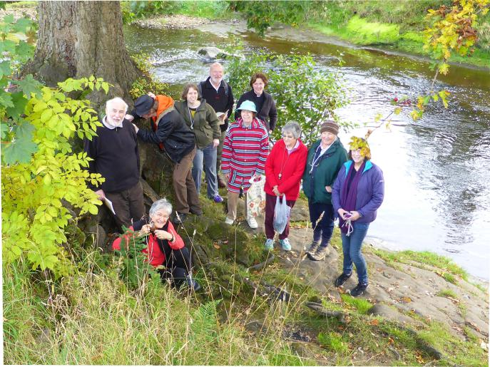

Eco Prayer Walkers, including the lichen expert, Judith Allinson (seated)

RESTORING THE EARTH

Green Christian in its November Prayer Guide gives “four key reasons why ecological restoration is the most important endeavour of our time”:

- To restore the health of our plants, crops and forests we need to revive our soils which have been degraded

- We need to restore a healthy relationship with Nature. Restoring

the ecosystems on which we depend enriches our relationship with the Planet

10

- Indigenous cultures and knowledge are being lost as well as biodiversity

- The restoration of ecosystems is intrinsically linked to the restoration of human health.

For reflection and discussion:Is Nature (the environment) our enemy to be tamed and domesticated? Or is it our ally and friend? And if so, how far can we trust it? And are we humans its master, its steward or what?

TAKING THINGS FORWARD

Would anyone like to join Timothy Fox and Andy Ive for an occasional (monthly?) Zoom prayer gathering to include some reflection, bible and other reading and a little bit of discussion and using the Green Christian Prayer Guide published monthly on their website, giving information – both good and bad news – for each day of the week and a prayer each Sunday?
Tel. 015242 – 62575, or email: wenningfoxes@btinternet.com

ECO-JUSTICE

Slave labour was used to clear forest in the Caribbean for sugar plantations for the profits of UK and other European landowners and to boost the European economy.
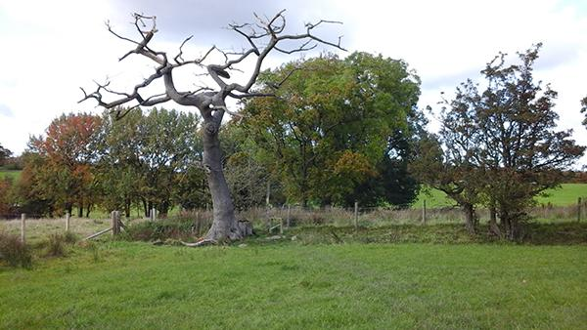

Is the Oak alive or dead? South of Goodenber Park

Carbon emissions from our industry, etc have affected the climate in countries like Tanzania bringing long droughts, more intensive heavy rainfall and rises in sea level, with impacts falling most heavily upon the poorer parts of the population who have done least to increase carbon emissions.

Ordinary people in rural communities are bearing the brunt of the damage done by 11

bauxite mining in Jamaican rainforests – deforestation, loss of biodiversity, pollution of water, soil and air, affecting people’s health and livelihood.

These are just three examples of the eco injustices affecting the “Two-Thirds World” – because of the ways in which the richer world has run our industry, business, trade and politics – reported in a recent edition of Koinonia, the new magazine for USPG, the United Society for Partners in the Gospel.

MAKE COP COUNT

Next November, the UK will be hosting the international climate conference,

COP 26, in Glasgow.

Rachel Mander who works for Hope For The Future (HFTF)writes in

USPG’s new magazine, Koinonia: “Given the importance of the UK’s host role, the Committee on Climate Change (the UK government’s independent advisory body) has said, ‘It has never been more important for the UK to demonstrate strong climate leadership, both for the world’s future and for the UK’s standing within it.’”

In preparation for this, USPG and HFTF are inviting UK Churches and others to take action through the Make The COP Count - a project to get our MP’s on board. Please note there is a climate bill – early stages - going through Parliament this month, December . If you want to contact our MP, Julian Smith, write to Jemima Parker, our diocesan eco adviser, at jemima.parker@leeds.anglican.org – or the website, “The Environment Bill – How to talk to your MP”.
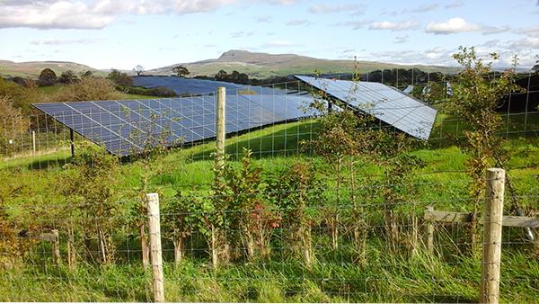

Solar Panels. East of Goodenber Park

