'CARING FOR GOD’S WORLD'

No 6 – September 2020.
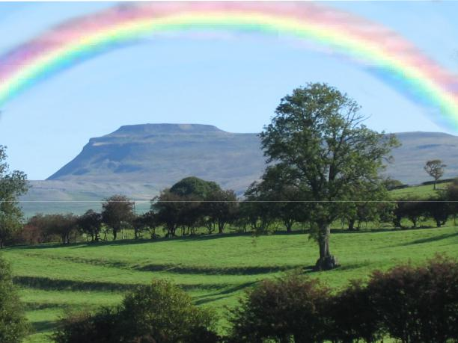

Creation Season

1st September - 4th October
Saint Francis of Assisi

CONTENTS

 | Page
Celebration, Lament and Hope | 2
Eco-House, Eco-School, Eco- Town…. | 8
Trees for Bentham | 8
As by a snow-bound lake | 9
Attention! | 10
Does 5G pose health risks? [plus websites] | 11

(Please note fuller (original) versions of 1st and Sheila’s article can be found on the

website: https://www.ingleboroughchurches.org.uk/aboutus/ecomagazine
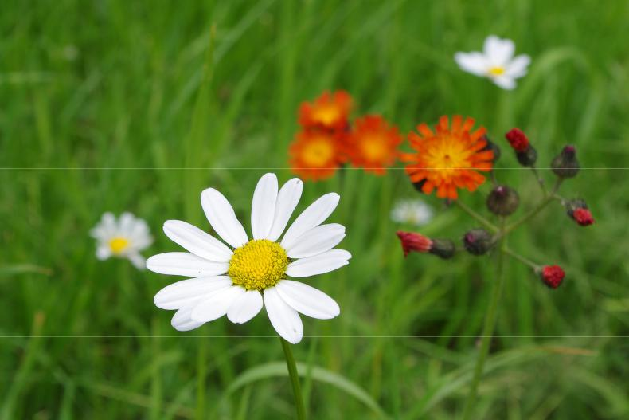

“The ultimate test of man ‘s conscience may be his willingness to sacrifice something today for future generations whose words of thanks will not be heard.” Quoted in the September 2020 Green Christian Prayer Guide.

2

CELEBRATION – LAMENT – HOPE

This is a report from a Zoom meeting of local Franciscans, part of the Yorkshire Third Order, SSF . They were asked to bring to the meeting stories and experiences that expressed their celebration, lament and hopes for the environment, God’s world and how humans relate to the natural world.

CELEBRATION

S set us off. He said he was starting off from the belief that God is everywhere and we are part of creation. Over the years God has been speaking to him through nature, giving flashes of insight, like the flashes you might see of a kingfisher. “I looked out of the window of the truck in the Philippines and saw a large, red flower and thought: God has put that flower there for his enjoyment - and for mine”. Another time in the desert he described when the sky was ‘white with stars’. Then there was this surprise of Coronavirus. It came at Easter and it was as if we were experiencing Easter - Crucifixion, Resurrection, Ascension and then the coming of the Holy Spirit. Suddenly the story of Emmaus was a revelation, it made sense.

Through gardening God has given him continuous awareness of His presence - growing things from seeds and nurturing plants, noticing every blossom, every fruit. Getting right down to the ground, seeing things close up. Giving thanks for each fruit. Almost like continuous prayer and praise. Sharing the produce with neighbours was a real pleasure.

When walking, he can read the contours and scenery - wood tracks, landscape, weather, clear air. Fresh air was a surprise through lockdown. All the local walks provided surprises - deer, a cuckoo, a calf being born, cantering cows, a hare, rainbows. ‘I have learnt how to stroke a bumble bee.’ An imprint of where something has been - an animal laid on the ground, tracks. ‘God delights and surprises me’.

D felt, like S, that COVID echoed Lent and Easter. Found it a time of intense prayer - waking in the early hours to pray. From the house there is a spectacular view from their balcony. In those early hours she could see all the lights of Keighley, then watching the arrival of dawn. She felt God’s glory surrounding us and all the events that are happening.

A said she had been watching Gardener’s World and saw an interview with a woman whose body had been affected by thalidomide, she had no arms.

3
She was positive and inspirational, talking about the joy she gets from her garden, noticing all the tiny changes that are happening, such as a leaf unfurling. A felt that God was speaking to her through that woman. A enjoys her garden but is often focused on noticing all the jobs that need to be done, rather than spending time taking pleasure in what she can see. She felt the message to her was to slow down and to appreciate. There is lots of wildlife locally - squirrels and deer. They love them very much even when they do eat the fruits of their garden. ‘We have all been finding something positive though lockdown’. Thanks to walking with her small granddaughters she has discovered wild raspberries. Walking slowly with small children means it has been possible to discover something new.

L described being delighted and surprised that nature exists in the form that it does. How beautiful, dynamic, varied organised and purposeful it is; how strong the sense is of God working within nature. Her early childhood eyes were opened by playing in the woods. She recalled lying on the grass, looking up and watching the birch leaves moving in the wind. As they moved she marvelled as the different colour of the underside of the leaves was revealed . It is where she first thought that nature is ‘made’. Nature has a loving purpose, made by a loving God. She told us about current Nature literature that focuses on ‘the little and the local’. She talked about a Benjamin Myers book about a single rock behind his house and all the natural life that can be seen relating to it. ‘Thinking about the little things I can focus, look at the detail and be still, finding God in the detail.’

E described the joy and delight in nature and the sense of the presence of God all around as she walks locally and further afield. About how at times that walking and sense of God’s presence feels prayerful and full of praise. Being out in nature, breathing fresh air has proved important for her physical and mental well-being. Looking back to her teenage years, when family life was complicated and not always pleasant, she had really enjoyed walking. Only now has she realised the important role it had played in bringing pleasure and in maintaining well-being.

T told us a story about when he and his wife and daughter were living in Tanzania. They had just put their little daughter, S, to bed when they heard laughter coming from her room. They peeped through the door and she was laughing at the fireflies dancing round in the dark. T said that this had shown him how ‘nature comes to us’ and we see things. The world is God’s gift to us.

4
LAMENT

S talked about his generation being a lucky generation. It was a generation that had come through a war and now it feels like we are at war again. We have reaped the benefits and access to goods but we have not looked after the world. When he was at agricultural college he was taught that farmers try to leave a farm in better condition than they found it. We are not doing that in terms of leaving the world in a better condition. He laments our inadequacy in doing that.

D feels that the time of lockdown has been a mixed blessing. People have been fly-tipping, an eyesore, a blight on God’s wonderful creation. The hope is that people will be educated that this is wrong.

A lamented the lack of generosity that some of her neighbours have demonstrated towards visitors to the place where they live. They live in a beauty spot and have been hostile to those coming to take exercise and find refreshment there. A felt that it was a shame that people couldn’t appreciate that not everyone lives in congenial circumstances. Their homes may be small with no outside space. She feels that a positive welcome would have helped to talk to people and encourage them to take their rubbish home.

L’s lament, she said, was on a more global scale. Nature is so fragile and this is affecting adversely millions of lives. Injustice is a key part of it. She lamented the inactivity of governments despite them having power and influence. There is hope with lots of activity at the local, grassroots level. We need both grassroots change and government action and leadership. Governments are too willing to give up.

E talked about her experiences of being in California where climate change is affecting her family, first through the drought and then the wildfires. People seem to struggle to make change even when the evidence was ‘in their face’. She cited the profligate use of water during the drought; the lack of the use of solar panels or hanging out the washing rather using a dryer.

T commented that we suffer from the disease of ‘affluenza’! He too laments the inequality. The poorest half of the world’s population account for only 10% of emissions.

S talked about land ownership 4% of the population owning 80% of the land. He began his working life in agriculture, particularly plantations which often

5
provided a social infrastructure of education and healthcare. This , though, was paternalistic and colonial. In South America the Spanish grabbed the land and left the poor. He had moved from thinking that ‘large’ was good to realising ‘small’ is good. He was influenced by liberation theology. It is happening again as the rich get richer.

HOPE

D spoke about being more involved with her garden, and as a result, with her neighbours. In order to keep up with the work of the garden, neighbours were coming in to help. A microcosm of the neighbourhood was to be found in their garden.

A said she hangs onto the phrase: ‘As Christians it is our duty to hope.’ Hard to do because we often make the same mistakes.

L said that what gives her hope is the ingenuity of the human race. She described an ingenious project which was developed to ensure the supply of water right through the drought that happens before the monsoon rains arrive in the Himalayas. An ecologist had come up with the idea of creating ice towers made from the winter rains and glacier meltwater. As well, L drew our attention to a quote from the book ‘Cherishing the Earth’: ‘Christ will be alongside us as he holds together the very fabric of our world.’ Therein lies our hope. [ Margot Hodson and Martin Hodson pub.Monarch, 2008]

E is interested in businesses around the world that are trying to do well and to do good. A company in Denmark, Ørsted, transformed itself from a struggling oil and coal business to a cutting-edge wind energy company, increasing its net profits by some $3 billion per year. Ørsted’s long-term vision of itself as a green company not only inspires its people to perform, it helps its leaders keep its strategy on target. The Ørsted vision is a world that runs entirely on green energy. After selling off its oil and coal assets, Orsted became a model of reinvention.

S commented ‘I hope that people will have hope.’ That they will move forward rather than go backwards.

E shared some research that had been presented at a digital international conference. From their experience of the pandemic, many people have been left with a desire for change. And not only that they also felt that they had agency, that they could act to make a difference.

6
T cited Greta Thunberg as an example of someone acting in their own town that has had a profound effect. If we make change at a local level it puts pressure on the politicians. There are strong moves to make the recovery a Green recovery; for growth that is sustainable and moving away from fossil fuels. A move to a circular economy where things are re-made, repaired or recycled. God is in the world. Jesus is the sign of that. ‘What is impossible for God? The only thing that is impossible for God is to act contrary to his nature of love.’

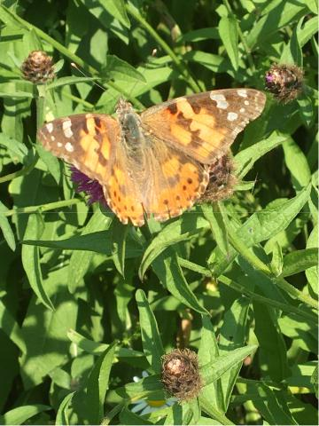

Butterflies Margaret Wilding
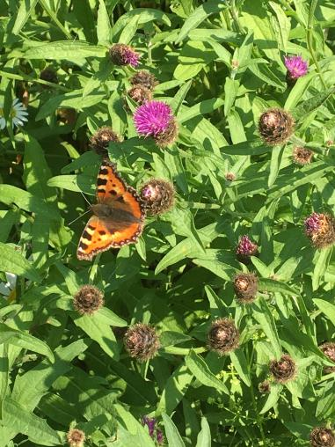

7
ECO-HOUSE… ECO-SCHOOL… ECO-TOWN…

ECO-EVERYTHING….

Every family and community needs to look after its surroundings or environment on which we depend. But we also want to care for the world around us, finding Nature therapeutic and peaceful, good just to look at and enjoy for its own sake. David Channing writes in a leaflet for anyone visiting Bentham Parish Churchyard:

“Be still and let nature speak. Listen to the birds as they move amongst the trees. Hear the wind around the building and in the tree tops – the river as it rushes towards the sea in flood, or babbles slowly by at times of low rainfall.
You may hear buzzards mewing as they fly above or, on some still evenings, tawny owls calling to each other. Be inspired by the colour and variety of the wild flowers that appear at different times of the year…. A local botanist and
artist, Doris Cairns, [who has had books published on the churchyards at St Mary’s Ingleton and Giggleswick] found over 50 different kinds of wild flower.”

The next 4 or 5 issues of this eco magazine will focus on the “Eco-Church” promoted by A Rocha, a Christian charity that encourages churches, schools and others to care for their part of this beautiful, rich but fragile Planet Earth. For churches there are 5 aspects – Worship and Teaching, Buildings (energy, etc), Land, Community and Global Engagement, and Lifestyle.

TREES FOR BENTHAM

Many of us have noticed that a lot of ash trees are dying from some kind of disease conveniently called ash die-back, but had you heard that some beetle or fungus is also now attacking oak trees in the South of England? Hopefully it will not spread further north and a remedy can be found in time. So when we plant trees now ash is off the recommended list – and will oak also be off it too?

Plans are being laid to plant trees like birch, hazel and rowan on suitable sites in Bentham once we are given landowners’ permission. We will get support and a

8

free supply of whips (saplings) with instructions and advice from the Woodland Trust. A few people have offered to help and we would like others to come forward and community groups to help plan, plant and then maintain the trees. Some may be grown from seeds. Anyone interested please contact Timothy Fox,

wenningfoxes@btinternet.com.

As By A Snow Bound Lake In Wales

As by a snow bound lake in Wales you may stand very still with outstretched hand focussing upon love

while a robin flutters round you

working his way towards trust

till finally for the briefest interval

you feel his feet upon your palm

as he touches down to take the bread and go

So may we wait in silent contemplation

in conditions of love and purity

open to the possibility of contact

offering our gifts

and recognising if it comes

the subtlest touch of God

which as blessing

may yet remain indelibly upon our being

Pete Armstrong
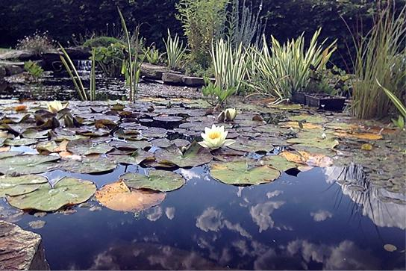

Pond by Jane Rolfe

9

Attention!

A National Trust Report published this year entitled ‘Noticing Nature’ asks “whether the biggest obstacle to saving the planet (and ourselves) is the fact that we’ve stopped noticing nature?” Interestingly, the research for the Report was undertaken in 2019 and it revealed that over ¾ of the children surveyed rarely or never watched the clouds, listened to birdsong or took time to notice butterflies or bees. Sadly, the adults surveyed fared little better. This led me to ponder two things: Firstly, if the survey had been conducted during lockdown in 2020 would we have seen a more encouraging response, and secondly, now the noise and busyness is returning to life, are we, in the desire to return to a ‘normal life’, returning to old habits of failing to notice nature?
If we fail to pay attention to the natural world around us, we are in danger of ignoring what is happening globally. The impact of our inattention locally and globally should be a source of deep concern to all of us, especially those who believe God has trusted us with caring for his creation. We cannot care if we do not notice! When we fail to notice we become oblivious of our interconnectedness with nature and with each other; people and places thus become vulnerable to exploitation.
Resisting exploitation, both of the resources in our lands, and the people who work them requires a re-imagining of our world and a commitment to a new and radical kind of care. Any Environmental ambitions we have, therefore, must be rooted in an understanding that our current destructive way of organising society, in which big businesses and powerful states use their power to exploit, steal from and damage ecosystems and communities, is the cause of rising temperatures and sea levels, increases in catastrophic weather events, and the creation of climate refugees, mass migrations of peoples rendered homeless and often stateless because their land will no longer sustain them.
We need to take notice of current research that suggests that just 20 companies have been responsible for 35% of all carbon dioxide and methane emissions since 1965. This is one of the greatest injustices of the climate crisis: seven and half billion people pay the price for powerful companies making record profits. The result is that those who have done the least to create the climate crisis - communities living mostly in the Global South -feel its effects most catastrophically.
Resisting and challenging such injustice requires we find ways to transfer power away from the monopoly of big corporations into the hands of those who live on the land, tend it, care for it and depend on it. We believe that climate change activism needs to be built on a re-imagining of our world as a place where we centre our care for each other and the natural world, and respect and understand our place in the ecosystems which we inhabit. Such an
10
approach means rejecting the systems which require us to compete with our neighbour and take from our environment without giving back.
We need to draw on the knowledge of our farming communities, as well as the indigenous peoples and stewards of lands across the globe. Communities which depend on each other, working alongside the ebb and flow of the seasons and experiencing the patterns of birth, growth and death by which all of nature lives. These are people whose livelihoods, families, communities and faiths depend on being aware of our surroundings and our symbiotic relationship with it.
It is time to pay attention, start noticing what is right before us, then lifting our eyes to the global challenge that confronts us all.
Rosie and Evie Russell-Cohen and Sheila Hunter
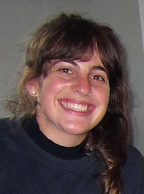
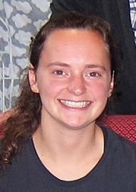
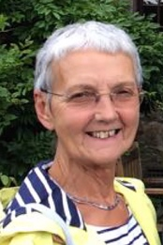

DOES 5G POSE HEALTH RISKS?

The following extracts are from the organization headed by Dr Firstenberg in the USA. I have also attended anti 5G meetings in the Diocesan office in Leeds. Please read and make your own mind up about the morals of the satellites now being launched and the fact that every lamppost in a city may become a transmitter and therefore a radiation emitter.

The signatories to the anti 5G Appeal are scientists, doctors and environmental organizations from every continent who have been working tirelessly for many years to call the world’s attention to an invisible assault on our biosphere. That assault can be ignored no longer.
11

5G—the 5th generation of wireless technology—must not be built on Earth or in Space. The notion that radio frequency radiation, commonly known as radio waves, is somehow not real radiation and is harmless, was disproven by the 1970s in laboratories all over the world, and the harm to humans, animals and
plants has since been confirmed in over 10,000 peer-reviewed studies. If 5G is built, radiation levels will increase 10- to 100-fold, virtually overnight, everywhere. There will literally be no place on Earth to hide from it.

The effects of levels of radio frequency radiation already existing now on the health of the population and the environment, as reflected in quality of life; high rates of cancer, neurological disease, heart disease and diabetes, even in children; plummeting populations of birds, bees and butterflies; and unhealthy forests, can be seen and felt everywhere

The 100,000 planned 5G satellites, each with a designed lifespan of 5 to 10 years, must be constantly de-orbited and replaced. This means that at least 10,000 satellites will have to be launched every year, forever into the future. If an average of 50 satellites can be launched on each rocket, that’s 200 rocket launches per year, just to maintain the satellites used for cell phones and Internet. And it means the de-orbiting of 10,000 worn out satellites per year, burning them up in the atmosphere and turning them into toxic dust and smoke. And that’s not counting the ever-increasing numbers of weather, research, tracking, monitoring, surveillance, military, and other kinds of satellites and missiles being launched in what will soon be a parade of rockets burning prodigious quantities of fossil fuels, punching holes in our atmosphere on a daily basis, and treating the source of all life as Earth’s largest garbage pit.

For sources of information and more facts – go to these websites: https://www.alerte.ch/images/stories/documents/info/5G_Firstenberg_anglais.pdf https://www.5gspaceappeal.org/the-appeal https://www.jrseco.com/european-union-5g-appeal-scientists-warn-of-potential-serious-health-effects-of-5g/

Andy Ive

12
Timothy Fox comments: As Andy has indicated not all scientists agree on the health hazards. But do we really need ever faster and more complicated means of communication than we have already – and who will really benefit from this new technology?
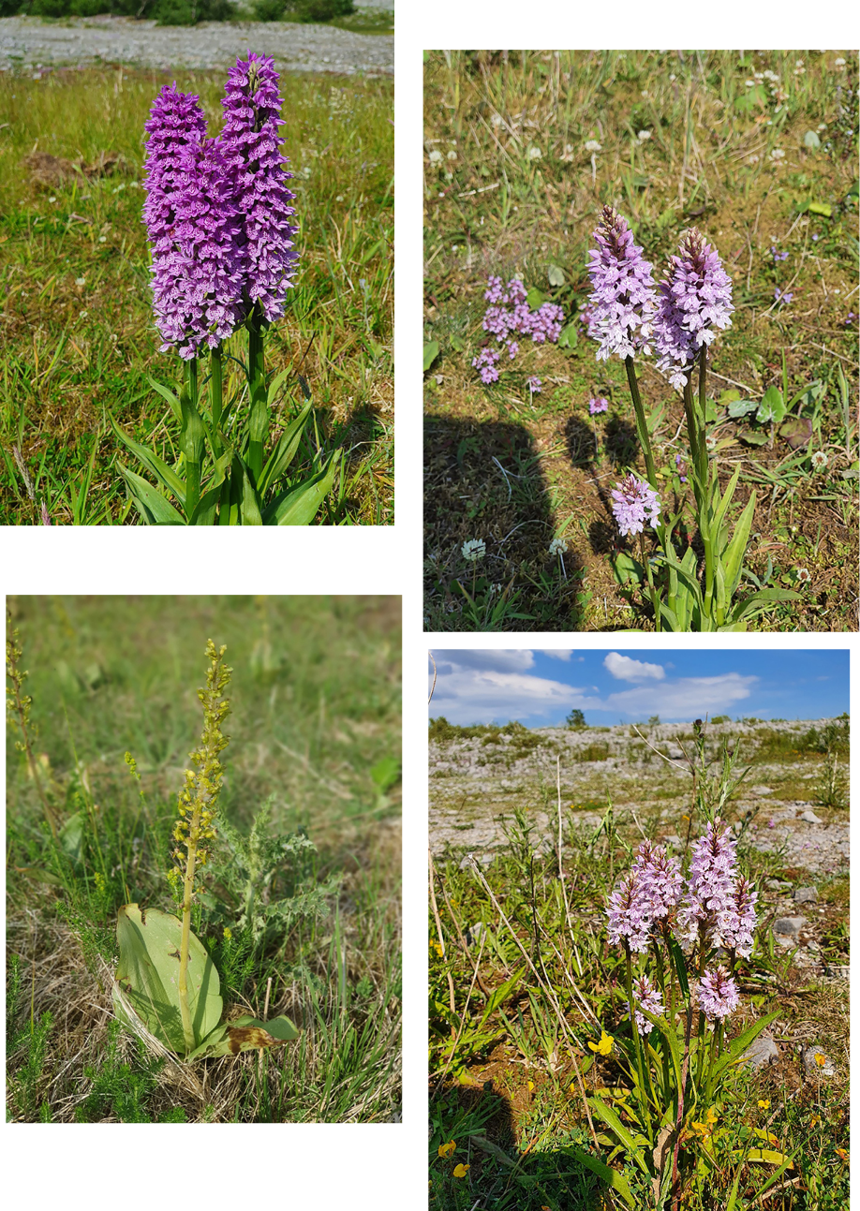

Orchids A C Barton

13

