'CARING FOR GOD’S WORLD'
No 4 – March 2020.
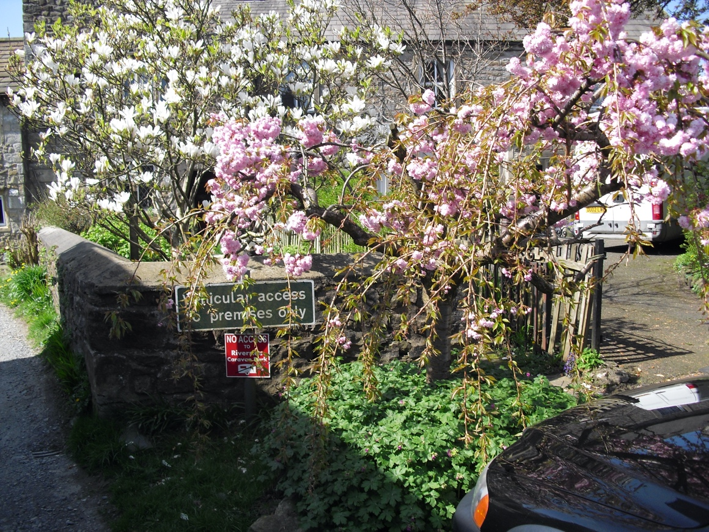

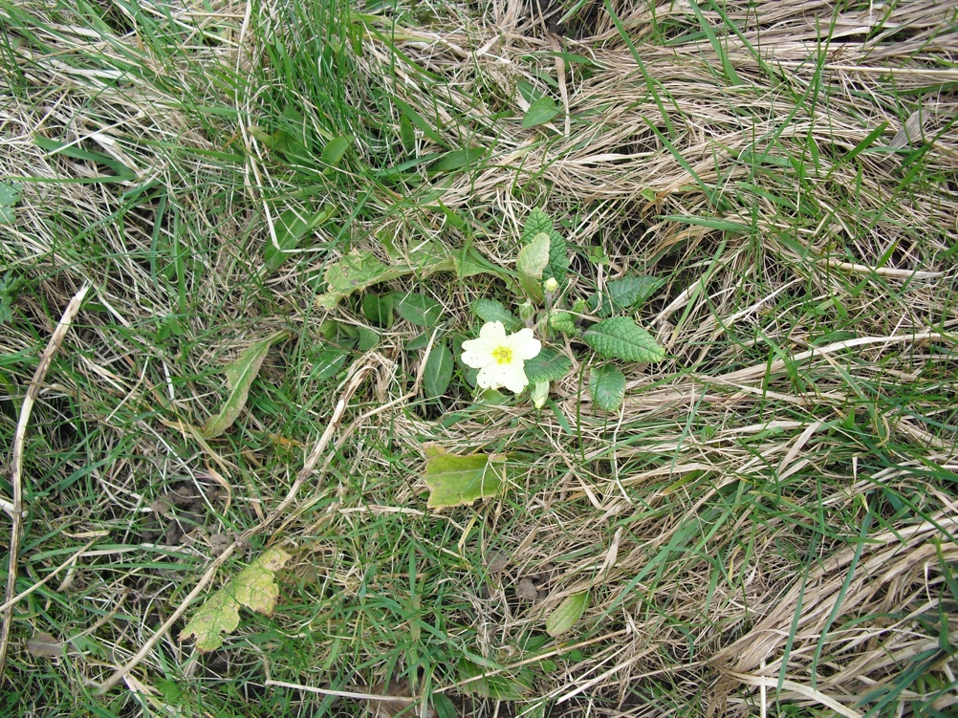

CONTENTS:
Some Good News Page 2
Eco Church in Low Bentham Page 3
Bee Together Page 4
Once in a Lifetime Page 4
UK Nature in Serious Trouble Page 5
Water Page 9
Global Carbon Levels Page 7
Coming Up Page 7
Various Reflections Page 7

Some Good News! The General Synod (sort of Parliament) of the Church of England voted
on 12th February to aim to reach net zero emissions of CO² (and other greenhouse gases) by 2030. This proposal originated with 2 parishes in Bristol and Bristol Diocese and was supported with prayer including a Christian Climate Action Vigil outside the Synod on the morning of the debate and with letters to Synod members.
And from the Green Christian Prayer Guide for January 2020:
(January 2nd) The EU is putting forward a Euro Green Deal providing a “roadmap” urging nations to boost the efficient use of resources by moving a clean, “circular” economy that covers all sections, notably transport, energy, agriculture, buildings and industry such as steel, cement. ICI, textiles and chemicals. [See below page 4for more on the Circular Economy]
(January 10th & 11th) Some farmers are following “agroecology” practices that work with the “grain of Nature”, for example using pesticides derived from plants
(January 25th) The World Wildlife Fund is working with local partners in China to reconnect over 50 lakes with the Yangtze river to improve water quality and wildlife.
(January 27th) A China government environment ministry official has recently confirmed that China will maintain its environmental protection goals including anti-pollution targets. [This – in spite of continuing use of coal] “It’s like … rowing a boat against the current,” Xu told a December 2019 media briefing in Beijing. But “we have no other choice but to go forward.”
What’s Happening Locally?
A small group of people from Bentham have been helping to lay hedges for a farmer near Halton …..
Following meetings with the Town Council in Bentham and an open meeting on February 15th there are plans to work on making the Town carbon neutral.
The Langcliffe Beekeepers
From the Craven Herald, 13 February 2020: Three years ago a village resident Kathy Davies invited a group of people to attend a talk on beekeeping; and the Langcliffe Beeks were born. They now have 3 active bee colonies in the Community Garden looked after by 21 “bee handlers” with others involved in fundraising, planting bee friendly plants and publicity .
In Bentham and Ingleton and other nearby villages plans are afoot to encourage bees and other pollinators by creating a sort of wild life corridor including churchyards.
The Circular Economy If we have a circular economy it means there is no such thing as waste. Everything can be used again and again. Imagine this as a circle: Recycle - Make - Use - Re-use - Remake - Recycle. This takes the place of the Linear Economy. Imagine this as a downward movement: Take – Make – Use – Dispose - Pollute If nothing is wasted, then any surplus is shared, used again, mended or repaired, or used for making other things, or for fertiliser or compost. In the circular economy we respect and use diversity in nature and in human talents and skills and social resources. We minimise extraction of raw materials and use only from renewable sources and/or from already existing sources. Older generations may recognise this as what we used to do anyway – and it what happens today in many areas of the world. For example in a Syrian refugee camp, people have made use of old foam mattresses in growing vegetables hydroponically, that is with very little water and without soil. Recycling , if this means putting stuff into the blue bin, is a last resort, because it takes energy to process the paper, glass, etc. But recycling could mean using again and again.
ECO Church In Low Bentham
Last year, 2019, St John’s were awarded silver in the Eco Church scheme, run by A Rocha. Eco is short for ecological, that is, sustainable, caring for the Planet and for the habitats of animals and people.This is a summary of their report based on our returns – in 5 sections:
1. Worship and Teaching: Much of our worship and some of our teaching includes eco elements, such as the intercessions – in children’s activities such as the (anti-)plastics banner used in the Bentham carnival. The PCC have made a formal commitment to being an eco-church.
2. Buildings: Limited because we are listed, we cannot put in insulation or double glazing, but we have measured our energy use and calculated our carbon footprint. We now get our electricity and gas supplied from renewable sources through a diocesan scheme. The Rectory is fully insulated and double-glazed. Some cleaning products are eco-friendly. We use recycled paper for printing.
3. Community and global engagement. A lot of this is with individuals and local environmental groups. Fair Trade products used and promoted. Some car sharing. Three editions of the magazine/newsletter, Caring For God’s World were published in 2019. Doris Cairns of Ingleton has done an informal survey of plants in the graveyard but not yet in Snowdrop Field.
Some information about wider world issues is shared. Timothy Fox has been on 3 conferences about responding to the climate crisis.
Some of the food we offer is LOAF, local – organic – animal-friendly – fairly traded.
4. Lifestyle
We have been encouraged to reduce car travel, energy consumption, waste ; and to buy LOAF.

Bee Together,“Bee Together” is a project for churchyards in the Ingleborough area facilitated by Catherine Mercer for the Yorkshire Dales Millennium Trust (YDMT), aiming to provide food and homes for bees, other pollinators and other wildlife. Some of our churchyards are already wildlife friendly – and have been for centuries!
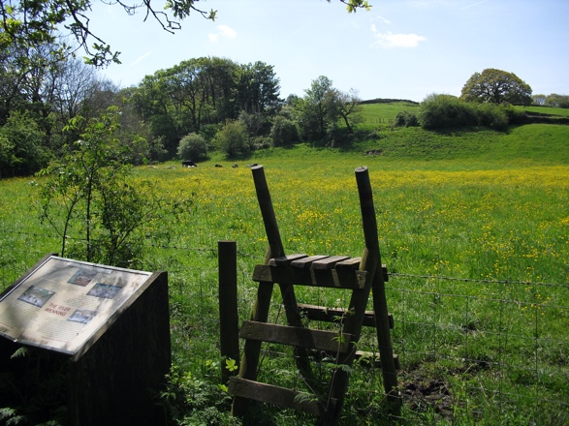

But we could also have “interpretation boards installed to engage visitors and help manage any perception of these areas as untidy.” Giggleswick and Tatham Fells (Lowgill) have useful boards. We can also contribute to national surveys such as The Big Butterfly Count. There are wildflower propagation workshops at Broadrake which are free – on Friday 1st May and Friday 18th September. Please contact Catherine Mercer by email: catherine.mercer@ydmt.org or by telephone: 015242 51002.

Once in a Life Time – Summary of the Cambridge Conference, September 2019 that Timothy attended with Robert Cohen
1. The title of the conference and most speakers reflected the URGENCY that we need to respond to the climate crisis with
2. Our response needs to be WITH OTHERS. … “cooperation, dialogue and mutual support”. There were many different organisations represented there, mostly Christian-based, and we need to work also with “secular” groups.
3. Our response needs to be ACROSS THE GENERATIONS - taking particular notice of what young people are already contributing.
4. THINK GLOBALLY, ACT LOCALLY.
5. Our response needs to include CHANGING ATTITUDES – our relationship with Nature.
6. Our response needs to include CHANGE OF LIFESTYLE.
7. In our responses we need to recognise many DIFFERENT FACTORS at play in the crisis or crises - poverty/inequality, race, war – AND GENDER.
LOCAL RESPONSES – as suggested by or from the conference:
• PRAYER – prayer walks, vigils, etc
• Share with PCC – Wanted: others to think, pray, plan and act !
• Nos 2 and 7 above, - with the complexity of the issues, maybe do ONE THING AT A TIME.
• Make use of existing contacts with young people. Ask young people what sort of world do you want to live in?
• Climate Zero City Game, Kickstart – board game
• Churchyard visits – for the wildlife.
• Conversations with Refugee Weekend visitors?
• What is happening to the climate in Sudan? Use of links?
• Work on ways to share all this with town groups, following up the moves earlier in the year to make Bentham carbon neutral at an open meeting to form action groups on Saturday April 18th, in the Town Hall.
• Tree planting….
• Rural Forum
• Use of media, including radio/TV – in consultation with Andy Ive, Jemima Parker & the diocesan group.

UK Nature in Serious Trouble
I am writing this on a bright sunny day in early February with very welcome signs of Spring in the garden, and of birds preparing for nesting. It all seems that it is ‘business as usual’ and in keeping with Genesis 8 verse 22: “As long as the earth endures, seedtime and harvest, cold and heat, summer and winter, day and night will never cease” (NIV). It is very reassuring that this is God’s intention but tragically mankind has not lived up to its responsibilities to be good stewards of creation, and it is increasingly important that all Christians take caring for nature as part of our discipleship.
Without doubt climate change is affecting the seasons and the behaviour of wildlife. Flowers such as snowdrops are blooming earlier in the Spring and oaks are leafing earlier; butterflies are appearing on the wing earlier; and there are signs that migrating birds are having to change their migration routes, or the places where they breed or spend winter, in response to the changing availability of the food they depend upon to feed their young.
Whilst we eagerly await the return of the swallow, they are arriving in the UK 15 days earlier than in the 1960s but are staying 2 weeks longer in the autumn. Great tits are resident in the UK but they are laying eggs 11 days earlier than 40 years ago.
Warmer weather has a double-edged impact. On one hand, migrants that breed in the UK are spreading northwards and we may also have an increase in species associated with southern Europe. However, those that live on mountain tops, such as Dotterel and Ptarmigan, are running out of space and could become extinct as breeding species in the UK. Woodlands risk losing Capercaillie, Brambling, Willow Tit, and Redwing. Farmlands could see the Turtle Dove become extinct.
All these alarming facts are reported in the State of Nature Report 2019 which also shows that the numbers of butterflies are down by 17%; moths are down by 25%; and more than 26% of UK mammals are at risk of disappearing altogether. (Rough estimates put the hedgehog population in England, Wales and Scotland at about one million compared with thirty million in the 1950s).
These are concerns for everyone, whatever our special interests might be and particularly for those who recognise our responsibilities in caring for God’s creation.
Revd. David Mann

Water
Well. We drink it, shower in it, spray the garden, water flowers, but do we really think about it?
In the UK we average 140L per person per day. The figure in Denmark by way of comparison is 80 L pppd.
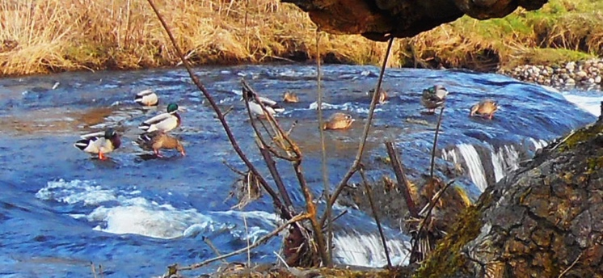
Water comes from several sources: rain obviously, that fills the rivers and reservoirs. Ground water, pumped up from the water table and then springs. A recent radio programme highlighted to me that the amount of waters in some streams and rivers is well below the average due to extraction upstream and this has a disastrous effect on wildlife.

Rivers carry water and nutrients to areas all around the earth. They play a very important part in the water cycle, acting as drainage channels for surface water. Rivers drain nearly 75% of the earth's land surface. Rivers provide excellent habitat and food for many of the earth's organisms.

Caddis Fly Lavae

There are certain indicator species such as mayflies and caddis flies, that give an indication of the health of a river, and the signs are depleting. Pollution from industry has lessened since the industrial revolution and the instigation of regulations to protect waterways has helped, but more needs to be done.
Recent flooding in the North of England may lead us to believe that there is no shortage, but of course floodwater is in the wrong place!!
So what can we all do to save water? A few simple actions:
• Use a rainwater collection system for garden watering
• Take shorter showers. A naval shower is where you get wet, switch water off, soap up and turn it on to rinse. Simple.
• Donate to Water Aid or Practical Action to help those in areas of drought.
• Use washing machines only on a full load
• Use a low flush toilet
• Eat less meat. The total amount of water needed to produce one pound of beef is 1,799 gallons; one pound of pork takes 576 gallons of water. As a comparison, the water footprint of soybeans is 216 gallons; corn is 108 gallons.
• Steam vegetables instead of boiling them
• Measure the amount of water going into the kettle. Only boil what you need

We will have a water shortage by 2050, if we do not all take action now.
Andy Ive
Global Carbon Levels
Andy Ive has just joined a training course called Carbon Conversations held in Leeds which will lead into a course for local churches and, Andy says, “hopefully for schools”. The course was developed in Cambridge in 2017 and since been upgraded and now “addresses all aspects of life with a personal calculator and a workbook to take you through the stages of understanding where we are going as a planet.” It’s clear we are all pushing out far more CO² and other greenhouse gases into the atmosphere than the Planet can cope with.
CO² Readings from Hawaii
The Guardian regularly publishes weekly averages of daily readings of global emissions of CO² readings measured at Hawaii which is a very long way from industry, etc. Scientists estimate the pre-industrial base as 280 parts per million (ppm) and the safe level for the Planet as 350 ppm. Weekly averages recorded 28 February 2010 were 390.45; 28 Feb 2019 were 411.22; 16 February this year were 414.01. The latest daily reading 27 Feb 2020 were 413.47. This shows that the average daily carbon emissions are increasing, and underlines the fact that we are in a climate crisis requiring urgent action from everyone, governments, businesses, local communities, churches and you and me, remembering this wonderful Planet Earth belongs to God and we are destroying it!

Coming Up
Future events:.
28-29 March 10 am – 4 pm. Celebration with exhibition of Malhamdale history
1st of April and 1st of every month Fast and pray for the Planet and its people and especially for the international climate conference in Glasgow in November –9.00 am venue and time to be announced.
12th April 6.15 am ~ Easter Sunrise Service at the Big Stone, Bentham ~ with Churches Together in Bentham
18 April 10.00 – 11.30 open meeting, Climate Action Bentham – Bentham responding to the climate crisis - action groups - in the Town Hall lower room.
22nd April Earth Day
3rd May 6.30 pm Christian Aid Service at Bentham Methodists ~ with focus on the climate crisis
11th – 17th May Christian Aid Week
7th June Open Farm Sunday
Various Reflections
Various Reflections:
Harmony in creation:
“… everything of God finds its proper place in him without crowding. Not only that, but all the broken and dislocated pieces of the universe – people and things animals and atoms - get properly fixed and fit together in vibrant harmonies, all because of his death his blood that poured down from the cross.” (Eugene Peterson’s paraphrase of Colossians 1:19-20.) We could add: … and all because of his resurrection which is the first act of God’s new creation.
Jesus is Lord of all:
“If I believe in God’s son and bear in mind that he became man, all creatures will appear a hundred times more beautiful to me than before. Then I will properly appreciate the sun, the moon, the stars, the trees, apples and pears as I reflect that he is Lord over, and centre of, all things.” (Martin Luther)
Why did God create butterflies?
“You ask, ‘What is the use of butterflies?’ I reply: to adorn the world and delight the eyes of man; to brighten the countryside like so many golden jewels. To contemplate their exquisite beauty and variety is to experience the truest pleasure. To gaze enquiringly at such elegance of colour and form devised by the ingenuity of nature and painted by her artist’s paints is to acknowledge and adore the art of God.” John Ray, biologist and Christian thinker, in The Wisdom of God manifested in the Works of Creation, 1691.
And are they also pollinators?
Thanks to Dave Lewis for setting up and printing.
What did you think of this edition? Please contact Timothy Fox, tel 015242 62575 or email wenningfoxes@btinternet.com

