'CARING FOR GOD’S
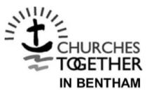
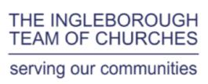
WORLD'

No 3 – September 2019.

This Autumn edition of Caring For God’s World focuses on farming. We are grateful to our farmers not only for the food they supply but also for the way they manage the land and care for their livestock. A lot of misinformation is put about concerning the carbon and methane emissions from cattle especially. What we hear is a statement of the global figures which are not true of British farming. George Dunn, chief executive of the Tenant Farmers Association gives a corrective to the usual image, and Chris Weston, a farmer at Rathmell who also manages Brocklands woodland burial site writes about organic beef farming. We also include what I have called “The Ingleber Charter” for anyone who wants to make a definite commitment to change some aspects of their lifestyle that may help Planet Earth and respond to the challenges of the climate crisis. This can of course be adapted – added to – as your circumstances change.

Timothy Fox.
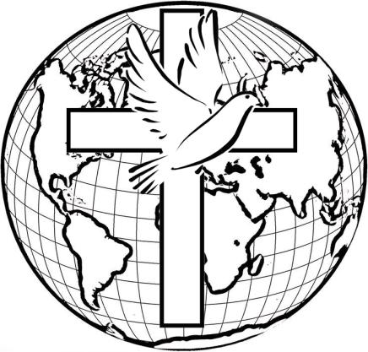

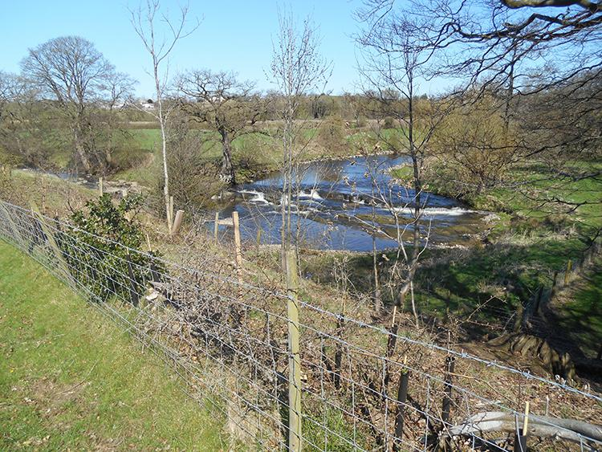

CONTENTS:

Carbon emissions and agriculture, George Dunn
Farm Facts
Organic Farming, Chris Weston
Cattle, wetlands & wildlife
Swarth Moor project
Use of Land – the global scene
The Ingleber Charter
Overshoot Days

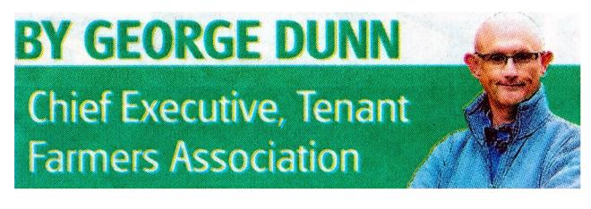

Eat more meat if you want to save the planet.

George Dunn writing in the May 2019 Farmer wants to correct the usual image of farmers reflected in statements that agriculture accounts for 25 per cent of our carbon emissions. That might be true at a global level, but UK government reports that of the UK’s 468 tonnes of carbon dioxide emissions, only 10 per cent are from agriculture. He goes on to say: “Through its landmass, agriculture is also a major store of carbon. More than 10 million hectares of grassland across the UK on which livestock and dairy productions takes place is storing something like 600 million tonnes of carbon. … This grassland is also responsible for the sequestration of around 2.4 tonnes of carbon dioxide each year….

“Transport alone [on the other hand] accounts for nearly three times more carbon emissions in the UK than agriculture… Of course people should be free to choose vegan or meat-free diets if they wish but not in the belief that in doing so they are saving the planet through the false premise of carbon offsetting.

“I’m not saying agriculture should be exempt from looking at how it can improve its performance in terms of carbon emissions, sequestration and storage, but this must be done from a sensible and well-informed basis.” Editor’s footnote: BBC Radio 4 broadcast an interview with an NFU representative on 10th September about their proposals to make British farming carbon-neutral by 2040.

In the beginning, God created the heavens and the earth… And God

saw that it was good…. Genesis 1

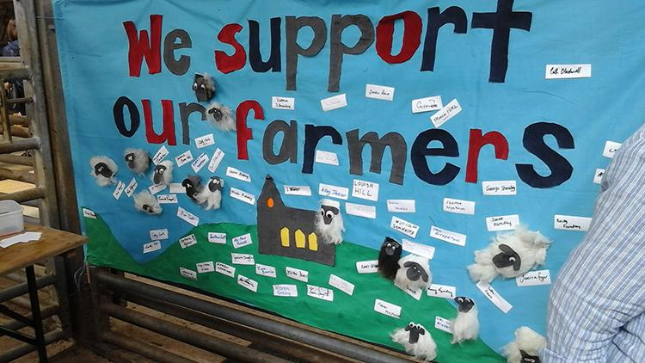

This banner was made at the Bentham Show as a sign of our support for our
farmers.

Did You Know these Farm Facts?

- Farming is the bedrock of the UK’s food and drink sector which contributes £122 bn to the country’s economy.

- British farming provides 61 % of the food eaten in the UK

- A total of 66 % of farm businesses in England also run other enterprises such as farm shops, wedding venues and B & B’s generating an income of £680m in 2017-2018 to the UK economy.

- About 75% of crop plants require pollination by insects and animals and UK farmers have planted wildflower habitat the size of 10,000 football pitches to provide homes and food for bees.

- Nearly 40% of farmers and growers are using the sun, wind, farm
by-products and energy crops to produce clean, low-carbon energy.

Organic Farming

The concept of Caring for the Planet and the much-debated issue of climate change have since the turn of the year been thrust into the forefront of the political limelight. From the recent rise of veganism, fuelled by the post-Christmas abstinence of ‘Veganuary’, and the more recent protests under the banner of ‘Extinction Rebellion’, the idea that the human race is facing Environmental Armageddon is gaining popularity.

Much as I applaud the fact that many young people are taking an interest in their natural surroundings and becoming engaged in environmental issues, it must be said that many of the thoughts and ideas upon which these movements are based, derive from misinformation and are simply untrue. I think it is the job of the Agriculture Industry as a whole to put the record straight and to counter some of the more extreme arguments.

As an organic livestock farmer who has the privilege to live and work in this beautiful part of the world, I regard it as my duty to help convey that message, by explaining to the public, local inhabitants, fellow citizens and to customers what we do and why we do it and how our farming impacts upon the planet.

We farm 200 acres of permanent grassland, 70 acres of mixed woodland and also have the Natural Burial Ground, Brocklands Woodland Burial. The land was converted to organic status in 2002 after our dairy cows were slaughtered as a result of the Foot and Mouth epidemic of 2001. We now have a herd of pedigree Hereford cattle producing grass-fed organic beef which is mainly sold through nearby farm shop outlets.

Veganism has moved from being a dietary choice to becoming an evangelistic movement with the aim of converting the whole world population to a plant-based diet. Perhaps they are unaware that in our part of the world, due to the topography and climate, arable farming is not viable; and this is true of two-thirds of the UK land mass – it is only suitable for grassland. If we don’t keep cattle and sheep what would become of our much-loved English countryside?

Cattle (and their keepers) are vilified because of the methane gas emitted in the rumination process which contributes to greenhouse gas emissions. But this should be seen in context: ruminants kept on natural permanent pasture, without the use of chemicals for fertility and weed control are in fact an asset to the environment. Undisturbed grassland acts as a carbon sink, and avoiding the use of artificial fertilisers encourages biodiversity of plantlife and wildlife. If inputs are kept to a minimum and when possible sourced locally, and products are sold in local outlets, thus minimizing food miles, this again redresses the balance.

When we work out our carbon footprint it is generally a small one, and in years when we plant a lot of trees we have a negative footprint, which means our greenhouse gas emissions are more than offset by carbon sequestration in our woodlands and permanent grassland.

Set this against the idea that we can all live off plants only, which would require us to be dependent on intensive arable farming, with its dependence on fossil fuels and heavy use of chemicals. This would be bad for biodiversity and detrimental to soil health.

The world with its rapidly expanding population faces great problems in providing sustainable food production and distribution, but we should beware of being taken in by extreme or over-simplistic solutions.

He has showed you, O mortal, what is good.

And what does the Lord require of you?

To act justly and to love mercy

and to walk humbly with your God.
Micah 6

CATTLE TURN WETLANDS INTO WILDLIFE HAVEN

The once unproductive farmland at Park End Moss, near Kendal has been turned into a ‘service station’ for migrating birds to breed,
including the bittern, one of England’s rarest species. It’s also a place where visitors can enjoy seeing wildlife, and has provided National Trust tenants with another string to their bow.
Lying on the western edge of the trust’s Sizergh Estate, Park End Moss covers about 30 hectares. With funding from Natural England, as part of an agricultural stewardship scheme new wetland was created by digging a series of channels and pools in the low-lying land, with the higher land being left for grazing. A reedbed was created by the RSPB. A £300,000 grant was used to create water-retaining bunds and sluices, ditches, channels, pools and scrapes. Sam Stalker, National Trust manager for Sizergh said: “The land is owned and managed by us working with tenant farmers, David and Rob Willison who farm next to the site and who have experience of a smaller wetland scheme there….Their Galloway cows are very happy carrying out

conservation duties on the wet grassland next to an area of reed beds… The site also acted as an area of water storage in the floods of December 2015… The full article can be seen in the May 2019 Farmer. Please ask Timothy for a copy.

SWARTH MOOR WETLAND PROJECT GIVEN GO-AHEAD

[reprinted with some slight amendments from Craven Herald, report by Pip Pointon – source ARC News Service]

The farmers who have grazing rights on Swarth Moor, near Helwith Bridge, were not consulted before Natural England applied to the Yorkshire Dales National Park Authority for permission for a restoration project which will include the creation of water-filled ditches.

The Authority’s planning committee heard that Natural England’s project would involve the construction of peat bunds for re-wetting raised mire and the excavation of three ponds for great crested newts.

Stainforth and Horton-in-Ribblesdale Parish Council and Austwick Parish Council had objected to the application because the graziers hadn’t been consulted. Concerns about hazards to the livestock and about an increase in the number of visitors had been raised. Swarth Moor commons rights holders had said they were concerned about the long term management of the moor and the impact on graziers’ livelihoods …

But a parish council appointee, Chris Clark, spoke from his own personal experience: “We’ve blocked 125 hectares and the results of that have been an increase in biodiversity, improved irrigation and carbon sequestration. On top of that we have had absolutely no problems with the stock getting stuck or drowned.”

The committee was informed that as common land was involved, Natural England would have to obtain the consent from the Secretary of State…

The application was approved by the Park Authority.

Where your treasure is, there your heart will be also… No one can serve two

masters…. You cannot serve God and wealth (mammon). Matth 6

THE GLOBAL SCENE

What is the IPCC? The Intergovernmental Panel on Climate Change is a UN body established in 1988 to determine the state of knowledge on climate change. It has more than 190 member countries. The panel assesses the risk of human-induced climate change, potential impacts and possible options for prevention. One of the solutions they propose is halting the destruction of forest, peatlands and wetlands, together with obviously planting of trees and reducing waste. A recent article in The Guardian Weekly has a chart showing usage of the planet’s land.

[please use chart or if not practicable, include the following]

28% is unused – of that some is barren, some primary forests, some grassland and wetlands.

Humans use 72% of the planet’s land. 37% grassland, 16 % used savannah and grassland, 19 % extensive pasture and only 2% intensive pasture. 22% plantations and other used forest. 12% is cropland, mostly non-irrigated and only 1% settlements.

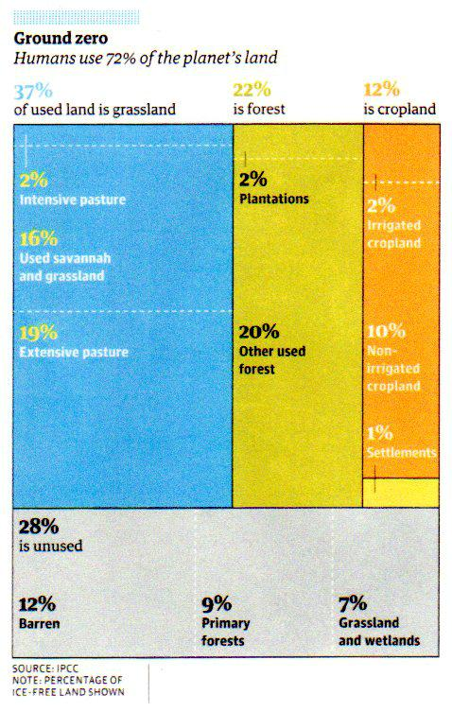

Then I saw a new heaven and a new earth… Now the dwelling of God is with people and he will live with them… Then the angel showed me the river of the water of life … flowing from the throne of God… On each side of the river stood the tree of life … And the leaves of the tree are for the healing of the nations… Revelation 21 & 22

THE INGLEBER CHARTER

These are some practical suggestions for changing our lifestyle in response to the climate crisis. “I commit myself to at least one of the following from the 2 sections: personal, 1-5 – and church/community/national, 6-10”. Please adapt them as you think right.

- I commit to LOAF: buying only/mostly Local, Organic, Animal Friendly and Fairly Traded products.

- I commit to eating mostly pasture-fed meat and sustainably caught fish

- I commit to reducing my energy consumption and food waste at home

- I commit to no single use of plastic bags and to cutting out cling film.

- I commit to offsetting the environmental cost of my air travel, for example by tree-planting.

- I commit to sharing in local church moves to reduce our carbon footprint

- I commit to praying regularly for the Planet – eg, using the Green Christian Prayer Guide (Timothy Fox can provide a printed copy on request)

- I commit to supporting farmers in their care of the land by
giving to FCN (Farm Community Network) , by prayer and friendship

- I commit to supporting a community climate action group or environmental charity – eg, Craven Conservation Group, North Yorks. Millennium Trust, or A Rocha or Christian Aid

- I commit to joining in climate crisis campaigns – eg, Extinction Rebellion

The heavens declare the glory of God, the skies make known God’s handiwork. One day speaks to another, night to night imparts knowledge and this without speech or language or sound of any voice.

Psalm 19

OVERSHOOT DAYS

Holidays. We all love them. We have saints days, bank holidays, armed forces days, but who here knows what an overshoot day is??

Let me elucidate. An overshoot day is the day of the year in which a country uses up its annual allocation of resources. Lets look around the world. Qatar used its allocation on February 11th, the USA on March

15th, the UK on May 17th, and interestingly the poorer the country, the later in the year it happens till Indonesia in the middle of December.

See https://www.overshootday.org/newsroom/country-overshoot-days/ for a calendar by country

What does it all mean? Well, if we carry on in the UK as we are we will need 2 planets like earth to exist on.

What can you do?

Eat less carbon intensive meals, turn lights off, insulate houses, take less flights, purse a plant diet for some of the time….and PRAY for the planet, it needs your help. PRAY that politicians and industrial CEO’s come to their senses. PRAY for the Climate, and PRAY for the 20% of the world habitable land that will be wiped out by the sea level rise.

This is one version of the overshoot calendar. In 1990 we were almost balanced as a planet, now with the global date being Late July, we need 2 planets like ours to live on.

